Hello, I’m Ajay Gautam and I am 3rd year Electronics Engineering student with expertise in PCB designing, hardware designing, embedded system designing, IoT, and embedded programming in C/C++ and Python. I am passionate about problem-solving and have a proven track record of delivering high-quality projects on time and within budget.

**Education:**

**-** CLASS X, VIDYA NIKETAN HIGH SCHOOL AMGAON Maharashtra State Board of Secondary and Higher Secondary Education (MSBSHSE) pass with 87 % in 2018.

**-** CLASS XII, VIDYA NIKETAN JUNIOR COLLEGE AMGAON Maharashtra State Board of Secondary and Higher Secondary Education (MSBSHSE) pass with 80.31 % in 2020.

- Bachelor's degree in Electronics Engineering from GH Raisoni Collage of Engineering Nagpur.

**INTERNSHIP / WORK EXPERIENCE**

Intern, BillEx.pvt.ltd, Dec 2022 - Present Intern, working as a Electronics Engineer where i'm designing PCB layout and circuits.

Muskurahat Foundation Dec 2022 - Jan 2023 Intern,

BETiC GHRCE Dec 2022 - Jan 2023, I currently work in lab and doing some projects.

**Skills:**

- PCB designing (Kicad, Proteus, Altium Designer, Eagle PCB and easyeda)

- Hardware designing.

- Embedded system designing (Microcontrollers, Microprocessors, ARM Cortex-M, Raspberry Pi)

- IoT

- Embedded programming in C/C++ and Python

- Problem-solving (Debugging, Troubleshooting, Root Cause Analysis)

- Web Development.

**Projects:**

- As a part of curriculum, I have design Home Automation System and smart agriculture devices :- using Raspberry Pi and ESP32/82. The system allows users to control and monitor the surrounding situation remotely using a mobile app.

- Medical Device: Device to Detect Sponge During Surgical Procedure. (BETiC lab)

- RF Harvesting. (BETiC lab)

- Woman Security Wearable Device. (Camera module) - safety and Security. (BETiC lab)

- Macropad – product (BillEx.pvt.ltd)

**Certifications and Awards:**

* Contraption competition, GHRCE SRC
* Terminator like Object Detection using Python and CNN, Devtown
* Recipe API Backend Web Development, Devtown
* Server Authentication Using Express and NodeJS, Devtown
* ROBO Soccer, GHRCE SRC
* Quiz competition, GHRCE NSS
* Avishkar competition, Avishkar Research Convention 2022-2023, RTMNU Nagpur

**Some of my design and work: -**

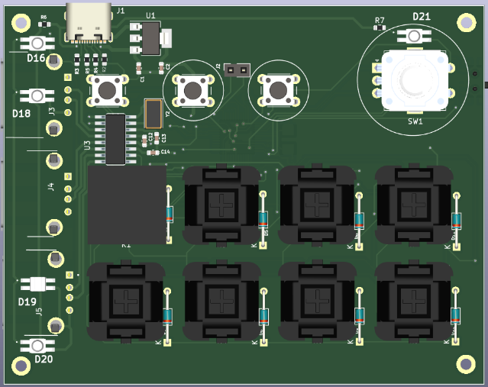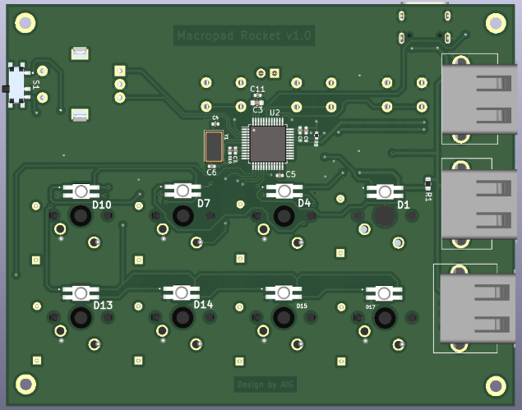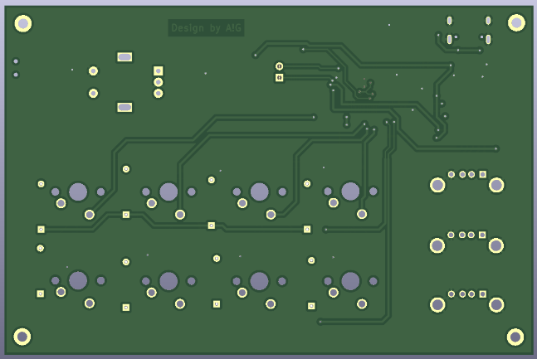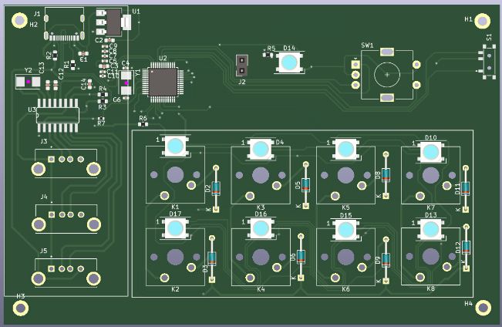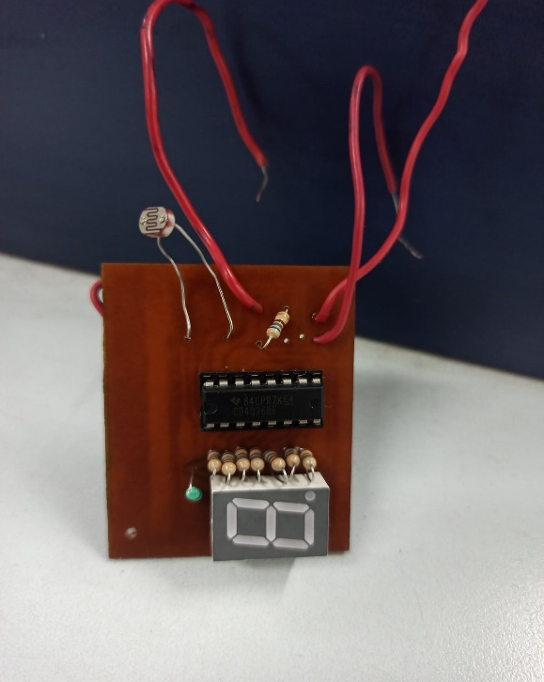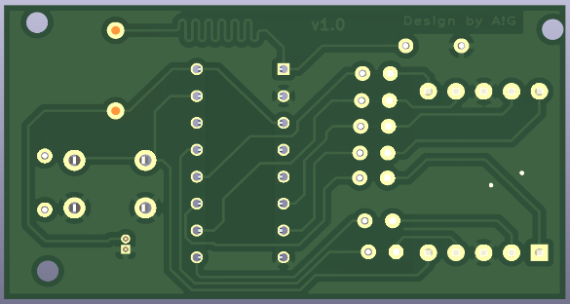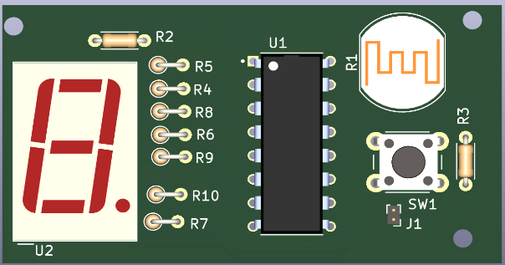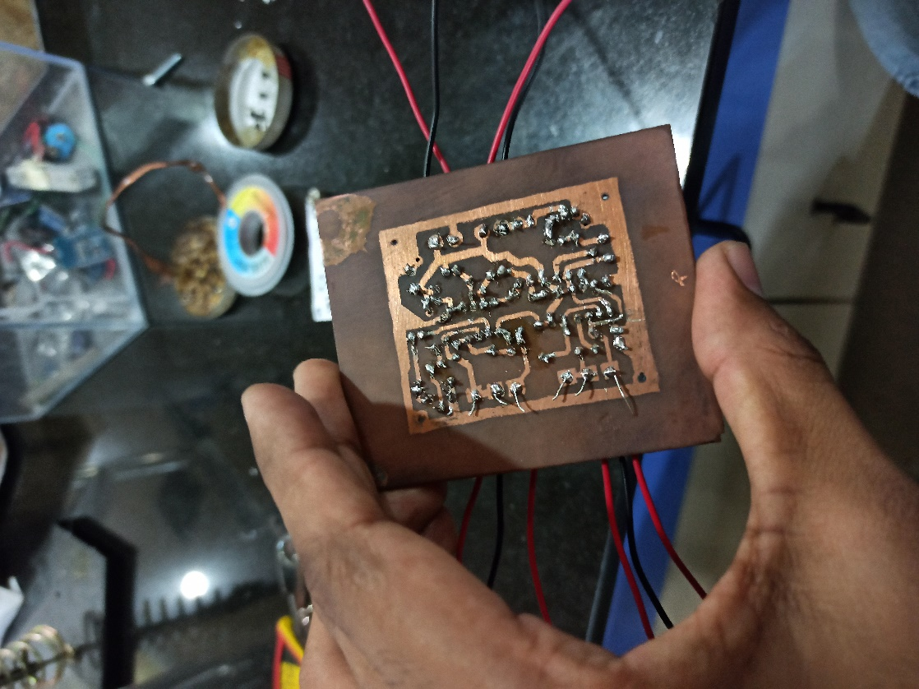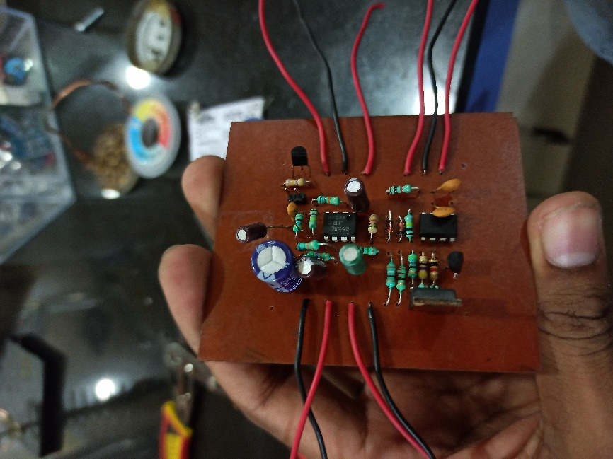

Macropad

V 2.0

V 3.0

0to9counterusingLDR v1.0

Metal detector circuit

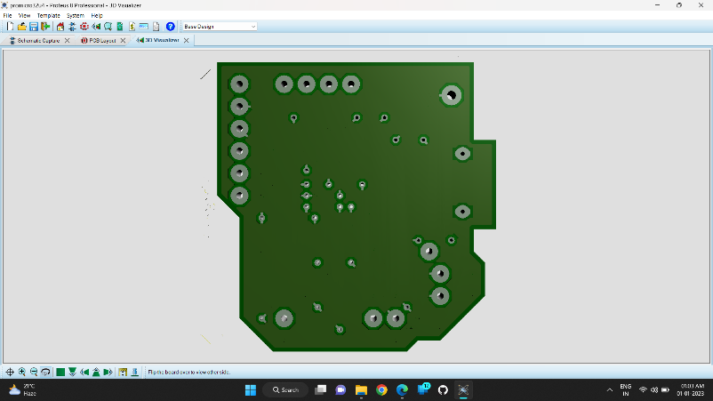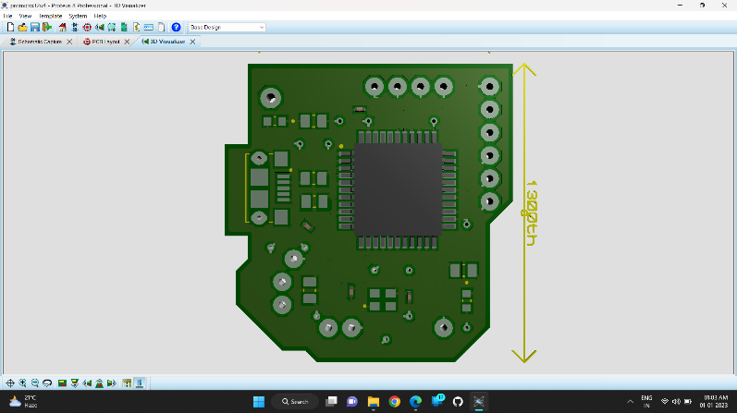

Development Board Atmega32u4